Generación kWh

Día

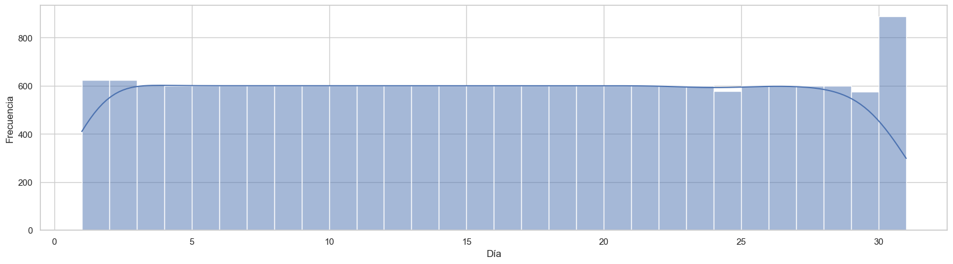

Año

Semana Año

Temperatura

Probabilidad de Lluvia

Humedad Relativa

Velocidad del Viento

Cobertura de Nubes

Índice UV

Condición del Cielo

Dirección el Viento

Velocidad de la ráfaga

Precipitación

DPT

